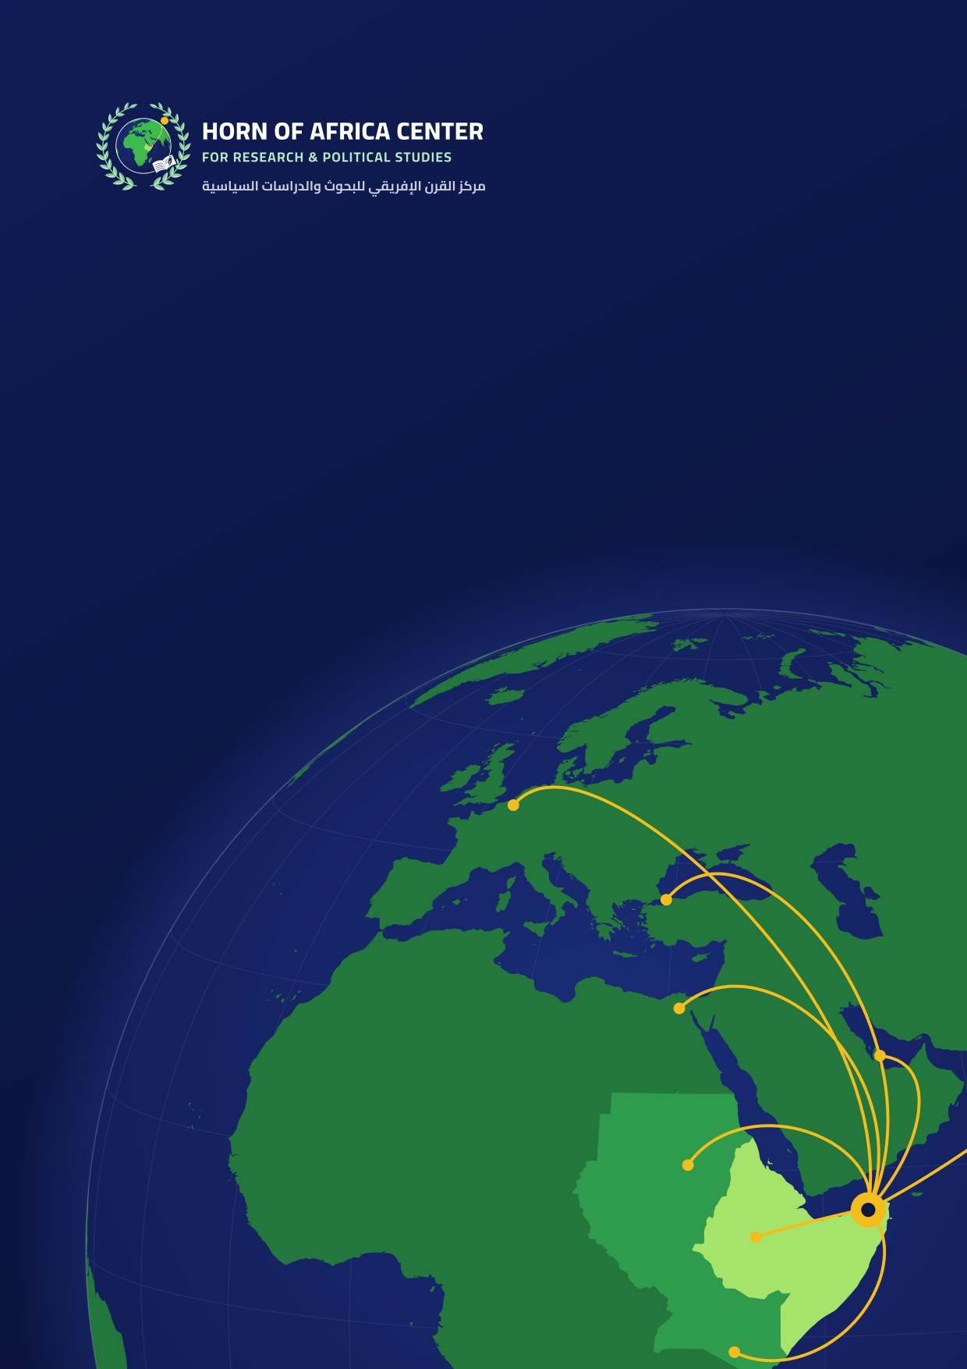
Institutional Profile
Horn of Africa Center for Research and Political Studies
A voluntary, independent research institution for the Horn of Africa and Somali affairs, based in Bosaso, Somalia.
2026

 The Center at a glance
A voluntary, independent research institution for the Horn of Africa and Somali affairs, based in Bosaso, Somalia.
  Who we are  A voluntary, independent research institution specializing in the Horn of Africa in general and Somali affairs in particular. |  |   Headquarters  Bosaso, northeast Somalia.
  Who runs the Center  A select group of researchers with diverse academic backgrounds and specializations. |  |   What we do  Research and studies, a monthly policy paper, periodic and foresight reports, seminars, an annual conference, and training.

  Vision  To be a leading research platform producing rigorous knowledge and studies on the issues of the Horn of Africa; to help develop solutions that respond to the challenges facing the region’s societies; to build active bridges of knowledge and thought with the Arab world; and to nurture new generations of researchers and writers while drawing on the expertise of the region’s scholars and intellectuals. |  |   Mission  To produce rigorous knowledge and strategic analysis of the central and pressing issues of the Horn of Africa, and to anticipate the changes of the present and the future, in ways that support decision-makers and help develop public policy, while raising the standard of scientific research and academic disciplines.

 About the Center
The Horn of Africa Center for Research and Political Studies is a voluntary, independent research institution. Its work is run by specialists in the affairs of the Horn of Africa in general and Somali affairs in particular, and it cooperates with all institutions and centers that share its goals and mission.
The Center’s headquarters is in Bosaso, in northeast Somalia. Its work is carried out by a select group of researchers with diverse academic backgrounds and specializations.

 Why the Center was founded
The Center was founded in response to the rapid changes the world is going through and the growing political, economic, social and intellectual challenges they bring, especially in Somalia and the Horn of Africa. Successive developments and overlapping regional and international interests call for independent national research institutions able to produce knowledge, analyze change and anticipate its direction and future effects.
Hence the need for a specialized research center that studies national and regional issues with rigorous scientific methods and provides evidence-based analysis and studies, helping decision-makers and actors in political, economic and social life to understand the challenges and to shape suitable policies and alternatives. The Center also aims to help close the gap in specialized research on Somalia by encouraging scientific research, attracting academic and intellectual talent, and building knowledge bases on the strategic issues that bear on the country’s future, security, stability and development.
The Center also studies Somalia’s position in its regional and international setting, analyzes geopolitical, economic and security shifts in the Horn of Africa, the Red Sea and the Gulf of Aden, and explores what they mean for Somalia’s national interests.
Because cultural and civilizational identity matters in building cohesive societies, the Center seeks to strengthen awareness of Somalia’s Arab and Islamic heritage, to promote the values of moderation, balance and coexistence, and to counter extremist ideas and distorted interpretations of religion through knowledge, dialogue and scientific research.
The Center therefore answers the need for an independent national research platform that combines scientific study, strategic analysis and foresight, advances knowledge about Somalia, and strengthens the country’s ability to understand and respond to the changes around it, in the service of stability, development and the national interest.

 Geographic scope
The Center covers the Horn of Africa in general and Somali affairs in particular, and studies Somalia’s place in its regional and international setting and the changes around the Red Sea and the Gulf of Aden.
Somalia | Ethiopia | Djibouti | Eritrea | Kenya | Sudan | South Sudan | Uganda

 What sets us apart
 A specialized team  Specialists in the affairs of the Horn of Africa in general and Somalia in particular. |  |  Based in Somalia  Our headquarters is in Bosaso, northeast Somalia.
 A bridge to the Arab world  We build bridges of knowledge linking Somalia with its Arab, African and international surroundings. |  |  Independence  A voluntary, independent institution committed to neutrality and objectivity.

 Our guiding policies
 Supporting decision-making  Preparing visions, public policies and strategic recommendations that help rationalize decision-making and make it more efficient and effective. |  |  Research excellence  Producing rigorous scientific research and studies, and publishing peer-reviewed periodicals and journals that meet recognized academic standards.
 Monitoring and foresight  Following the issues of Somalia and the region, tracking their geopolitical, economic and social dynamics, analyzing current changes and anticipating their future course. |  |  Neutrality and pluralism  Objectivity and impartiality in handling issues and information, openness to the full range of views in society, and balanced scientific study of them.
 Accuracy and method  Applying scientific method to collecting, verifying, analyzing and using information, with a commitment to accuracy, independence, research integrity and quality of output. |  |  Partnership and cooperation  Building cooperation and research partnerships with study centers, universities, institutions and relevant organizations to share knowledge and expertise and to develop capacity.
 Regional openness
Building bridges of knowledge and thought that link Somalia with its Arab, African and international surroundings, and promoting dialogue, understanding and the exchange of expertise on issues of shared concern.

 Goals
The Center’s main goals are pursued by publishing research and periodic reports across many fields of knowledge, guided by the following aims:
 | Support scientific research and encourage all research and study in political, economic and social fields related to the Horn of Africa, and Somalia in particular.
 | Follow new developments in the region and the geostrategic conditions that result from them.
 | Help shape public opinion in society and measure the views of intellectual elites on crucial questions.
 | Conduct opinion polls on public issues in the region and in Somalia.
 | Act as a bridge between scientific research institutions, and find common ground with other institutions for the exchange of knowledge.
 | Collect and archive rare information and maps on the history of Somalia and the Horn of Africa, and on the region’s relations with the wider world, especially the Arab world.
 | Organize purposeful research events and poetry evenings that raise awareness in Somali society, encourage scientific research and train people able to carry out research.
 | Publish scientific journals and periodic reports on Somalia and the region, such as the Center’s periodical, Sina’at al-Mustaqbal (Making the Future).
 | Form a generation of Somali researchers able to address Somali issues in a spirit of selfless national service.
 | Enrich the Somali library with valuable studies and research, provide accurate information about Somalia, and follow all forms of cultural activity in the region.

 Strategic goals
The goals of the Horn of Africa Center for Research and Political Studies are organized around seven strategic axes.
 Knowledge production and scientific research  Strengthening scientific research and producing rigorous studies and research in political, economic, social and strategic fields, with a focus on Somalia and the Horn of Africa. | Focus areas  Political research, economic research, social research, strategic studies, Somalia, the Horn of Africa.
Analyzing change and anticipating the future  Monitoring political, economic, security and social changes in Somalia and the region, analyzing their consequences and anticipating their future direction. | Focus areas  Political change, economic change, security, social change, foresight.
Supporting policy and decision-making  Providing evidence-based analysis, policy papers and recommendations that enrich public debate and support decision-makers on national and regional issues. | Focus areas  Policy papers, recommendations, evidence-based analysis, public debate, national and regional issues.
 Understanding society and public opinion  Conducting field studies and opinion polls, and analyzing the attitudes of society and elites toward priority national and regional issues. | Focus areas  Field studies, opinion polls, social attitudes, intellectual elites.
Capacity building and research partnerships  Developing a generation of researchers and specialists, and building partnerships with universities, think tanks and research institutions locally, regionally and internationally. | Focus areas  Researcher training, specialist staff, universities, think tanks, partnerships.
 Documentation and knowledge memory  Collecting, documenting and archiving sources, documents, maps and studies on the history of Somalia and the Horn of Africa, and making reliable knowledge available to researchers and the public. | Focus areas  Archives, documents, rare maps, history of Somalia, history of the Horn of Africa.
Dialogue and regional presence  Organizing events and intellectual dialogues, publishing periodicals and research reports, strengthening Somalia’s presence in regional and international research circles, and building bridges of knowledge with its Arab, African and international surroundings. | Focus areas  Intellectual dialogue, periodicals, regional presence, the Arab world, the African neighborhood.

 Means and activities
 Research and scientific publications  Research, studies, books and peer-reviewed scientific journals, along with specialized periodicals and reports. |  |  Policy papers  A policy paper every month on pressing and strategic issues in Somalia and the Horn of Africa, with analysis and practical recommendations for policymakers.
 Seminars and intellectual dialogues  Political and intellectual seminars and specialized dialogues on priority national and regional issues, open to a range of views and an exchange of expertise. |  |  Media and knowledge platform  A specialized media and research platform that publishes analytical articles, studies and reports and follows political and intellectual developments in Somalia and the region.
 Workshops and capacity building  Workshops, training sessions and programs that build the skills of researchers, writers and people interested in research, and encourage a new generation to produce knowledge. |  |  Periodic meetings  Regular analytical meetings to follow political and strategic developments and to exchange readings and assessments of fast-moving events in the region.
 Lectures and cultural events  Public lectures, cultural gatherings and discussion forums on intellectual, cultural and national issues. |  |  Exhibitions and knowledge events  National and regional exhibitions on heritage, history, culture and knowledge production that strengthen awareness of shared identity and memory.
 Annual conference  An annual conference that brings together researchers, thinkers, experts and policymakers to discuss strategic issues, exchange views and build a shared research agenda. |  |  Periodic and foresight reports  Periodic and annual reports that track change in Somalia and the Horn of Africa and offer an analytical, forward-looking reading of its likely course.

 Who we serve
   | Decision-makers and actors in political, economic and social life
   | Researchers, writers and people interested in research
  Universities, think tanks and research institutions
   | Relevant institutions and organizations
  Somali society and public opinion
  Readers in the Arab world and beyond who follow Somalia and the Horn of Africa

 How we work
We apply scientific method to collecting, verifying, analyzing and using information.
1 |  | Monitoring  Following the issues of Somalia and the region and tracking their geopolitical, economic and social dynamics.
2 |  | Collecting and verifying  Gathering information, field data and opinion polls, and checking them against reliable sources.
3 |  | Analysis  Analyzing current changes with rigorous scientific methods, objectively and impartially.
4 |  | Foresight  Anticipating the future course of change and its effects on Somalia’s national interests.
5 |  | Publishing and recommending  Publishing studies, policy papers and reports, and offering practical recommendations to decision-makers.

 Quality and research ethics
 | Objectivity and impartiality in handling issues and information, and openness to all views.
 | Accuracy, independence, research integrity and quality of output.
 | Peer review of journals and periodicals to recognized academic standards.

 Our team and areas of work
The Center’s work is carried out by a select group of researchers with diverse academic backgrounds and specializations.
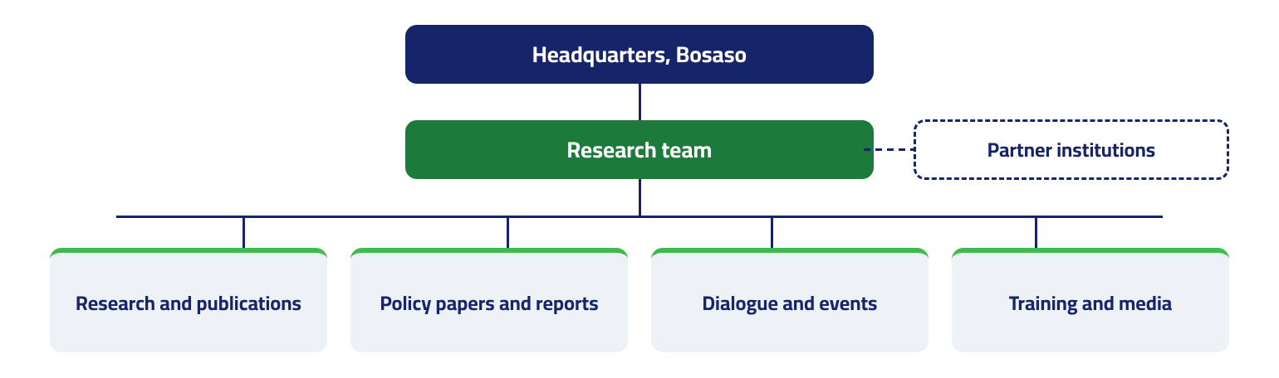
 | Headquarters, Bosaso | The Center’s main office, in Bosaso, northeast Somalia.
 | Partner institutions | The Center cooperates with all institutions and centers that share its goals and mission.
 | Research team | Researchers with diverse academic backgrounds and specializations who run the Center’s work.
 | Research and publications | Studies, books, peer-reviewed journals, periodicals and specialized reports.
 | Policy papers and reports | A monthly policy paper, and periodic, annual and foresight reports.
 | Dialogue and events | Seminars, lectures, periodic meetings, exhibitions and the annual conference.
 | Training and media | Workshops and training for researchers and writers, and the Center’s media and knowledge platform.

Partnerships
The Center cooperates with all institutions and centers that share its goals and mission, and builds cooperation and research partnerships with study centers, universities, institutions and relevant organizations to share knowledge and expertise and to develop capacity. Areas of cooperation include:
 | Research partnerships with study centers and universities
 | Exchange of knowledge and expertise
 | Capacity building and training a new generation of researchers
 | Joint seminars, dialogues and the annual conference
 | Bridges of knowledge with Somalia’s Arab, African and international surroundings

 Mission
To produce rigorous knowledge and strategic analysis of the central and pressing issues of the Horn of Africa, and to anticipate the changes of the present and the future, in ways that support decision-makers and help develop public policy, while raising the standard of scientific research and academic disciplines.

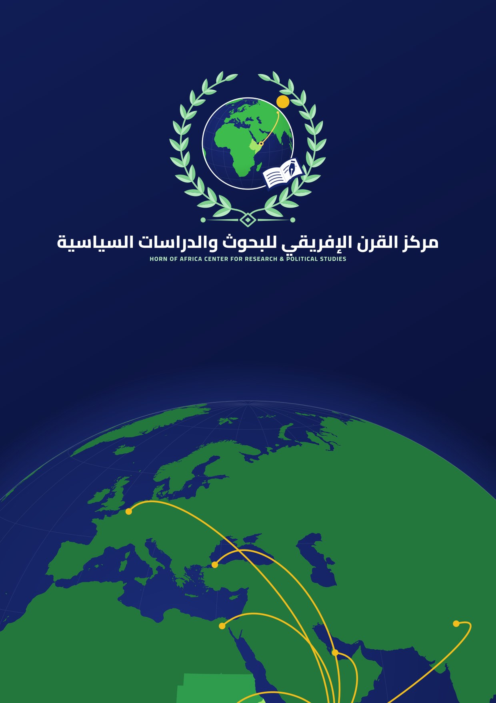
Contact us
We welcome inquiries from researchers, partners, journalists and institutions.
 Address: Bosaso, northeast Somalia
 Telephone: [+000 00 000 0000]
 Email: [info@yourdomain.org]
 Website: [www.yourdomain.org]

